Name: Hafiz M. Muneeb Akbar
Roll No: SU92-BSAIM-F24-048
Subject: Programming for Artificial Intelligence (LAB)

Lab Task 2
Spaceship Titanic---Machine Learning Pipeline
Code Documentation & Function Reference

Project Overview
This notebook implements a binary classification pipeline for the Spaceship Titanic Kaggle competition. The goal is to predict whether a passenger was transported to an alternate dimension based on personal records recovered from the ship's damaged computer system.

The pipeline follows a standard supervised-learning workflow: data loading and inspection, exploratory data analysis (EDA), feature engineering, preprocessing, model training with cross-validation, hyperparameter tuning via grid search, and final prediction export.

Dataset Description
Three CSV files are used throughout the notebook:

- train.csv — 8,693 labelled passenger records (14 columns). Used for model training and validation. The target column is Transported (boolean).
- test.csv — 4,277 unlabelled passenger records (13 columns). Used to generate final competition predictions.
- submission.csv — Output file created by the notebook, containing PassengerId and predicted Transported values for each test passenger.

Key columns in the dataset include PassengerId, HomePlanet, CryoSleep, Cabin, Destination, Age, VIP status, and five expenditure features (RoomService, FoodCourt, ShoppingMall, Spa, VRDeck).

Step 1 — Import Libraries
The cell imports all third-party packages needed for the pipeline and applies global configuration settings.

Library | Alias | Purpose
pandas | pd | Tabular data manipulation (DataFrames)
numpy | np | Numerical array operations
matplotlib.pyplot | plt | Low-level plotting and figure configuration
seaborn | sns | Statistical visualisation built on matplotlib
sklearn.model_selection | — | Dataset splitting, cross-validation, and grid search
sklearn.preprocessing | — | Label encoding and feature scaling
sklearn.ensemble | — | Random Forest and Gradient Boosting classifiers
sklearn.linear_model | — | Logistic Regression classifier
sklearn.metrics | — | Accuracy scoring and classification reporting
warnings | — | Suppresses non-critical runtime warnings

Configuration
sns.set_style("whitegrid")
Sets the global seaborn plot theme to a white background with grey grid lines, improving readability of all subsequent charts.

plt.rcParams['figure.figsize'] = (12, 6)
Sets the default figure width to 12 inches and height to 6 inches for all matplotlib plots, ensuring consistent sizing.

Step 2 — Load the Dataset
The training and test CSV files are loaded into pandas DataFrames using pd.read_csv().

train_df = pd.read_csv('train.csv')
test_df = pd.read_csv('test.csv')

pd.read_csv() reads a comma-separated values file from disk and returns a DataFrame. It automatically infers column data types (integers, floats, strings, booleans) and handles the header row. After loading, the notebook confirms the shape of each DataFrame: (8693, 14) for training data and (4277, 13) for test data, where the values represent (rows, columns).

Step 3 — Exploratory Data Analysis (EDA) and Preprocessing

3.1 Basic Dataset Information
The following DataFrame methods are used to inspect the raw data:

train_df.head()
Returns the first 5 rows of the DataFrame. Used to visually verify column names, data types, and sample values after loading.

train_df.info()
Prints a concise summary of the DataFrame including column names, non-null counts, and data types (dtype). This is the primary tool for detecting missing values — a column with fewer non-null entries than the total row count contains NaN values.

train_df.describe()
Generates descriptive statistics for all numeric columns: count, mean, standard deviation, minimum, 25th percentile, median (50th percentile), 75th percentile, and maximum. Useful for detecting outliers and understanding feature distributions.

train_df.isnull().sum()
Computes the number of missing (NaN) values per column. isnull() returns a boolean DataFrame; .sum() aggregates True values (which equal 1) per column, yielding the missing count for each feature.

3.2 Feature Engineering
New features are derived from existing columns to improve model expressiveness.

Cabin Splitting
train_df[['Deck', 'CabinNum', 'Side']] = train_df['Cabin'].str.split('/', expand=True)
The Cabin column contains composite strings in the format Deck/CabinNumber/Side (e.g., 'B/0/P'). str.split('/') tokenises each string on the '/' delimiter, and expand=True places the resulting tokens into separate columns. This extracts three semantically distinct features: Deck (ship deck letter), CabinNum (cabin number on that deck), and Side (P = Port or S = Starboard).

Total Expenditure
train_df['TotalExpenditure'] = train_df[expenditure_cols].sum(axis=1)
Aggregates the five onboard expenditure columns (RoomService, FoodCourt, ShoppingMall, Spa, VRDeck) into a single numeric feature representing total spending. axis=1 instructs pandas to sum across columns for each row rather than summing rows for each column.

Binary Flags
train_df['HasExpenditure'] = (train_df['TotalExpenditure'] > 0).astype(int)
Creates a binary indicator (0 or 1) that equals 1 if the passenger spent anything onboard. The boolean comparison produces True/False values; astype(int) converts them to integer form compatible with most classifiers.

train_df['IsAlone'] = (train_df['GroupSize'] == 1).astype(int)
Flags passengers who are travelling alone. GroupSize is derived from the group prefix of PassengerId (the digits before the underscore). A GroupSize of 1 indicates the passenger is the sole member of their booking group.

Age Grouping
train_df['AgeGroup'] = pd.cut(train_df['Age'], bins=[0,12,17,30,50,200], labels=['Child','Teen','YoungAdult','Adult','Senior'])
Transforms continuous Age into an ordinal categorical feature using pd.cut(). The bins parameter defines the interval boundaries and labels assigns a human-readable category to each interval. This discretisation can help tree-based models capture non-linear age effects more effectively.

3.3 Missing Value Imputation
Missing values are filled using the most appropriate central tendency measure for each column type.

df[col].fillna(df[col].median(), inplace=True)
Replaces NaN values in numeric columns (Age and expenditure features) with the column median. The median is preferred over the mean for these columns because expenditure data is right-skewed (most passengers spend little, a few spend a lot), making the median more representative of the typical value.

df[col].fillna(df[col].mode()[0], inplace=True)
Replaces NaN values in categorical columns (HomePlanet, Destination, Deck, Side) with the most frequently occurring value (mode). mode() returns a Series of modal values; [0] selects the first in case of ties.

df['CryoSleep'].fillna(False, inplace=True)
CryoSleep is a boolean column indicating whether the passenger opted for suspended animation. NaN values are imputed as False (the more common state) rather than using mode, which avoids introducing statistical noise in this specific binary feature.

3.4 Encoding and Scaling

Label Encoding
le = LabelEncoder() train_df[col] = le.fit_transform(train_df[col])
LabelEncoder converts categorical string columns into integer codes (e.g., 'Earth' → 0, 'Europa' → 1, 'Mars' → 2). fit_transform() learns the mapping from the training set and immediately applies it. The same fitted encoder is later used with transform() on the test set to ensure consistent encoding.

Feature Scaling
scaler = StandardScaler() X_train_scaled = scaler.fit_transform(X_train)
StandardScaler standardises features by removing the mean and scaling to unit variance. For each feature x, the transformation is: z = (x − μ) / σ, where μ is the training-set mean and σ is the standard deviation. This is critical for Logistic Regression, which is sensitive to feature magnitude, but has no effect on tree-based models which are invariant to monotonic scaling.

Step 4 — Model Training and Evaluation

4.1 Train/Validation Split
X_train_split, X_val_split, y_train_split, y_val_split = train_test_split( X_train, y_train, test_size=0.2, random_state=42 )
train_test_split() partitions the labelled training data into a training subset (80%) and a held-out validation subset (20%). random_state=42 seeds the random number generator so the split is reproducible across runs. test_size=0.2 specifies that 20% of rows go into the validation set.

4.2 Cross-Validation
cv_scores = cross_val_score(model, X_train_scaled, y_train, cv=5, scoring='accuracy')
cross_val_score() performs k-fold cross-validation on the training data. With cv=5, the training set is divided into 5 equal folds; the model is trained 5 times, each time using 4 folds for training and 1 fold for evaluation. The function returns an array of 5 accuracy scores. The mean of these scores provides a lower-variance estimate of generalisation accuracy than a single train/val split.

4.3 Models Evaluated
Three classifiers are trained and compared:

Logistic Regression
LogisticRegression(random_state=42)
A linear probabilistic classifier that models the log-odds of the positive class as a linear function of input features. Despite its name, it is a classification (not regression) algorithm. It serves as a baseline: if non-linear models offer minimal improvement, the added complexity may not be justified.

Random Forest
RandomForestClassifier(n_estimators=100, random_state=42)
An ensemble of decision trees, each trained on a bootstrap sample of the data with random feature subsets considered at each split. Predictions are made by majority vote across all trees. n_estimators=100 specifies 100 trees. Random Forest is robust to outliers and handles mixed feature types well without extensive preprocessing.

Gradient Boosting
GradientBoostingClassifier(n_estimators=100, random_state=42)
A sequential ensemble method where each tree is trained to correct the residual errors of the previous ensemble. Unlike Random Forest (parallel training), Gradient Boosting builds trees in sequence. It generally achieves higher accuracy than Random Forest but is more prone to overfitting and slower to train. This model was selected as the best performer in the notebook.

4.4 Model Evaluation Metrics
accuracy_score(y_true, y_pred)
Computes the fraction of predictions that match the true labels: (correct predictions) / (total predictions). Ranges from 0 to 1. Suitable here because the dataset has a roughly balanced class distribution.

classification_report(y_true, y_pred)
Prints a per-class breakdown including precision (fraction of positive predictions that are correct), recall (fraction of actual positives correctly identified), F1-score (harmonic mean of precision and recall), and support (number of true instances per class).

confusion_matrix(y_true, y_pred)
Returns a 2×2 matrix showing true positives, true negatives, false positives, and false negatives. Provides more detail than accuracy alone by showing where the model makes errors.

4.5 Hyperparameter Tuning
grid_search = GridSearchCV(base_model, param_grid, cv=5, scoring='accuracy', n_jobs=-1, verbose=1) grid_search.fit(X_train_scaled, y_train)
GridSearchCV exhaustively searches a predefined hyperparameter grid using cross-validation. For each combination of parameters in param_grid, it trains the model with 5-fold CV and records the mean validation accuracy. n_jobs=-1 enables parallel execution using all available CPU cores. The optimal configuration found was: learning_rate=0.1, max_depth=5, n_estimators=100, yielding a CV score of 0.8011 and a validation accuracy of 0.8649 (an improvement of 5.75 percentage points over the untuned model).

grid_search.best_estimator_
Returns the model object fitted with the best-performing hyperparameter combination, ready to use for prediction without further configuration.

4.6 Feature Importance
feature_importance_df = pd.DataFrame({ 'Feature': feature_names, 'Importance': final_model.feature_importances_ }).sort_values('Importance', ascending=False)
feature_importances_ is an attribute of tree-based ensemble models that quantifies each feature's contribution to reducing impurity (Gini or entropy) across all trees. Higher values indicate more influential features. Results are sorted in descending order and the top 15 are visualised with a horizontal bar chart.

Step 5 — Final Predictions and Submission

5.1 Retraining on Full Data
final_model.fit(X_train_scaled, y_train)
After hyperparameter tuning, the best model is retrained on the entire labelled training set (not just the 80% split used during evaluation). This maximises the volume of training data seen by the model before generating competition predictions.

5.2 Generating Test Predictions
test_predictions = final_model.predict(X_test_scaled)
Applies the trained model to the preprocessed test features to generate a binary prediction for each of the 4,277 test passengers. The output is a numpy array of boolean values (True = Transported, False = Not Transported). The notebook reports that 2,277 passengers (53.24%) were predicted as transported.

5.3 Creating the Submission File
submission_df = pd.DataFrame({ 'PassengerId': test_df['PassengerId'], 'Transported': test_predictions }) submission_df.to_csv('submission.csv', index=False)
Constructs a two-column DataFrame pairing each test passenger's ID with their predicted label, then exports it to a CSV file. index=False omits the default pandas row index from the output, which is required by Kaggle's submission format.

Summary of Key Results
Metric | Value
Training samples | 8,693
Test samples | 4,277
Best model | Gradient Boosting Classifier
Best hyperparameters | learning_rate=0.1, max_depth=5, n_estimators=100
Best CV Score (tuned) | 0.8011
Validation accuracy (tuned) | 0.8649
Final training accuracy | 0.8522
Predicted as Transported | 2,277 / 4,277 (53.24%)

Output Screenshot

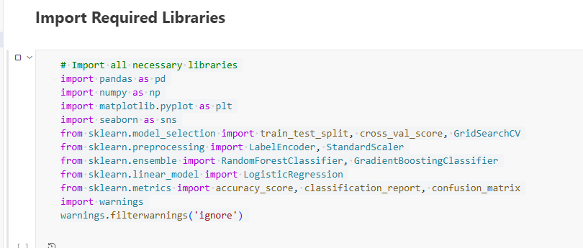
Figure 1: Importing the Libraries

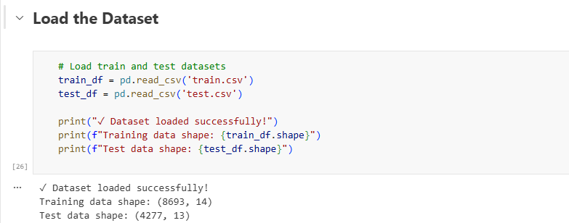
Figure 2: Data Loading

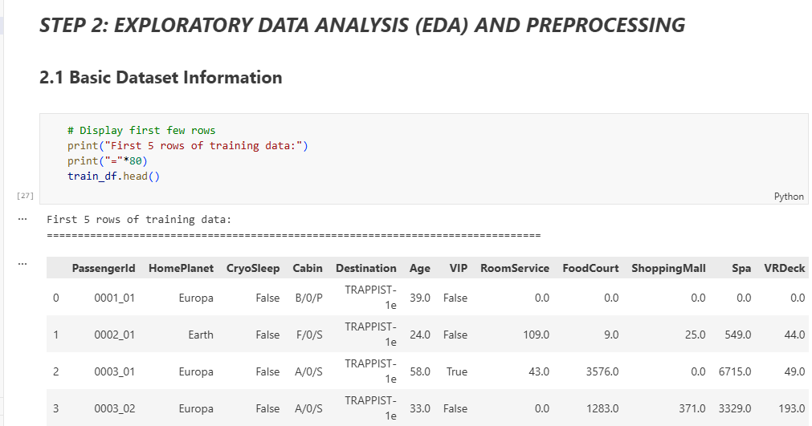

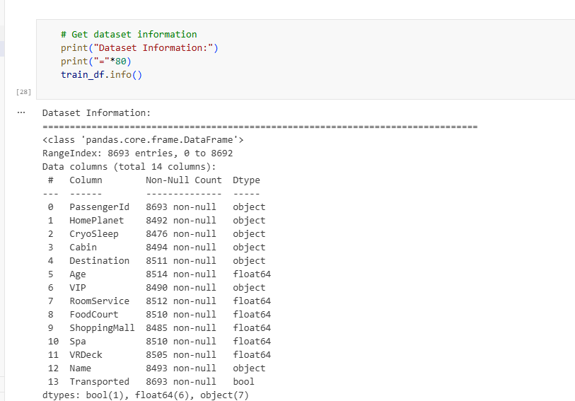

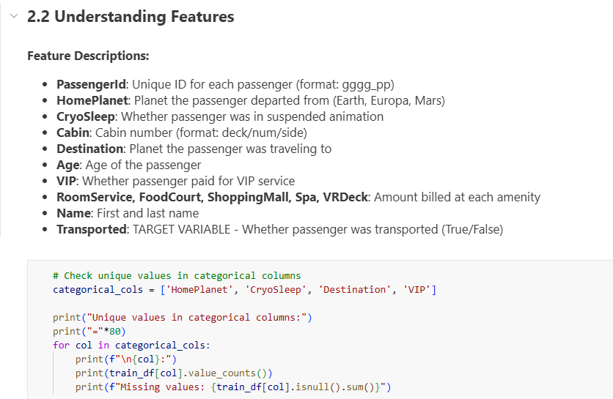
Figure 3: Step 2
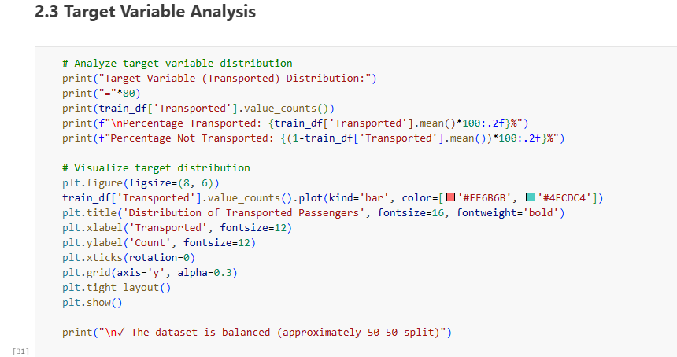
Figure 4: Target Variable Analysis.

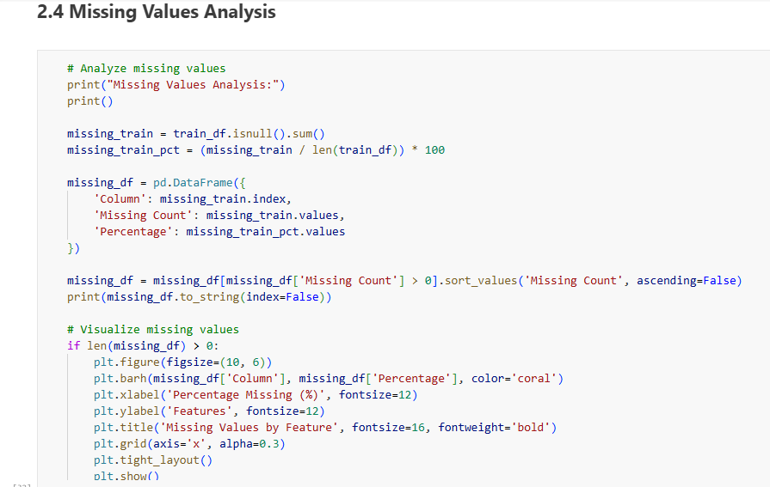
Figure 5: Missing Values.

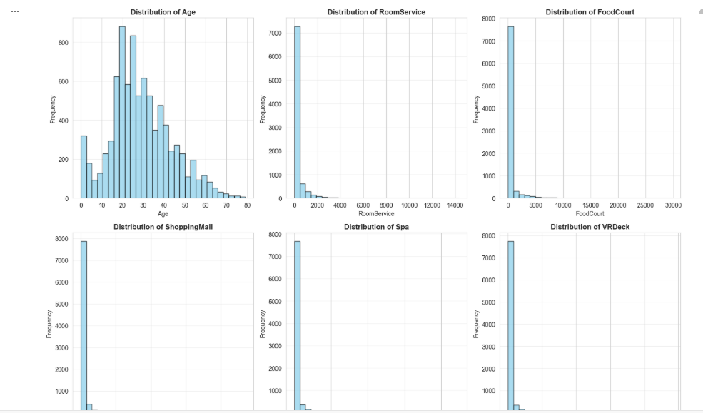
Figure 6: Numerical Feature Distribution.
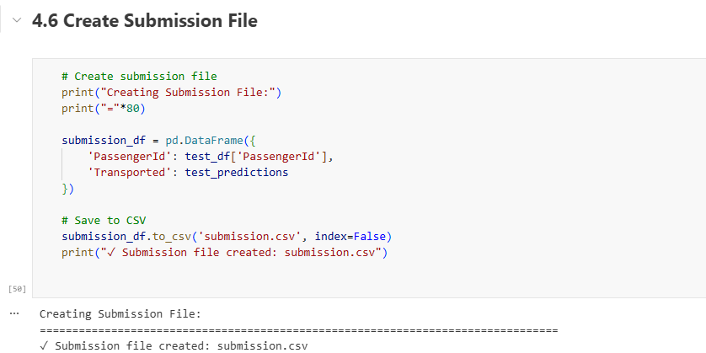
Figure 7: Submission File.

